**Read Bucket name using Lambda**

Steps:

1. Create 2 buckets in s3

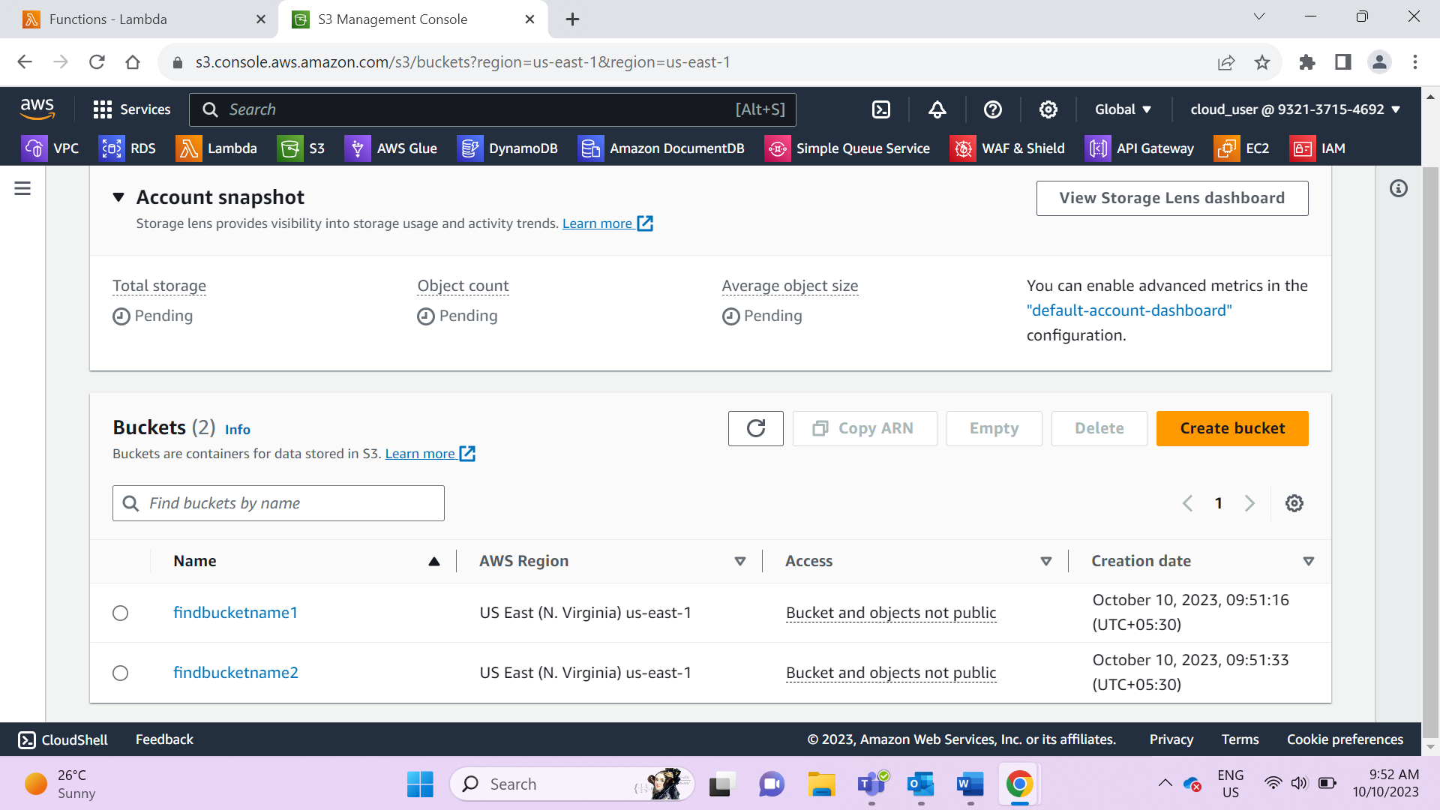

1. Add Role to lambda to allow read the buckets

* Go to Configurations 🡪 Permissions🡪 click on Role name
* Click on add permissions , search for s3ReadOnlyAccess and select & Save it

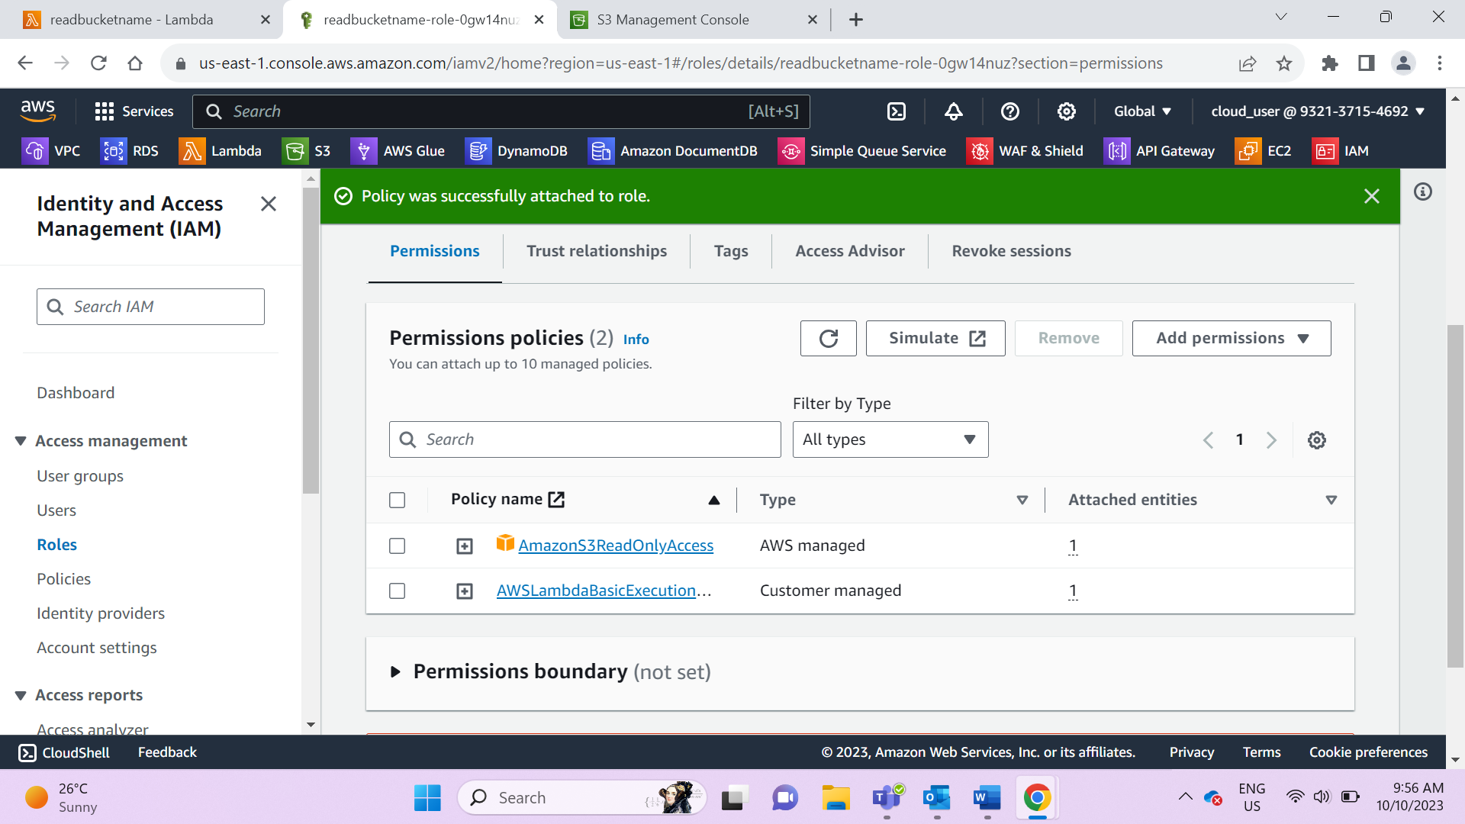

1. Write python code in Lambda to read the bucket

* Click on deploy , add configuration test event and click on test

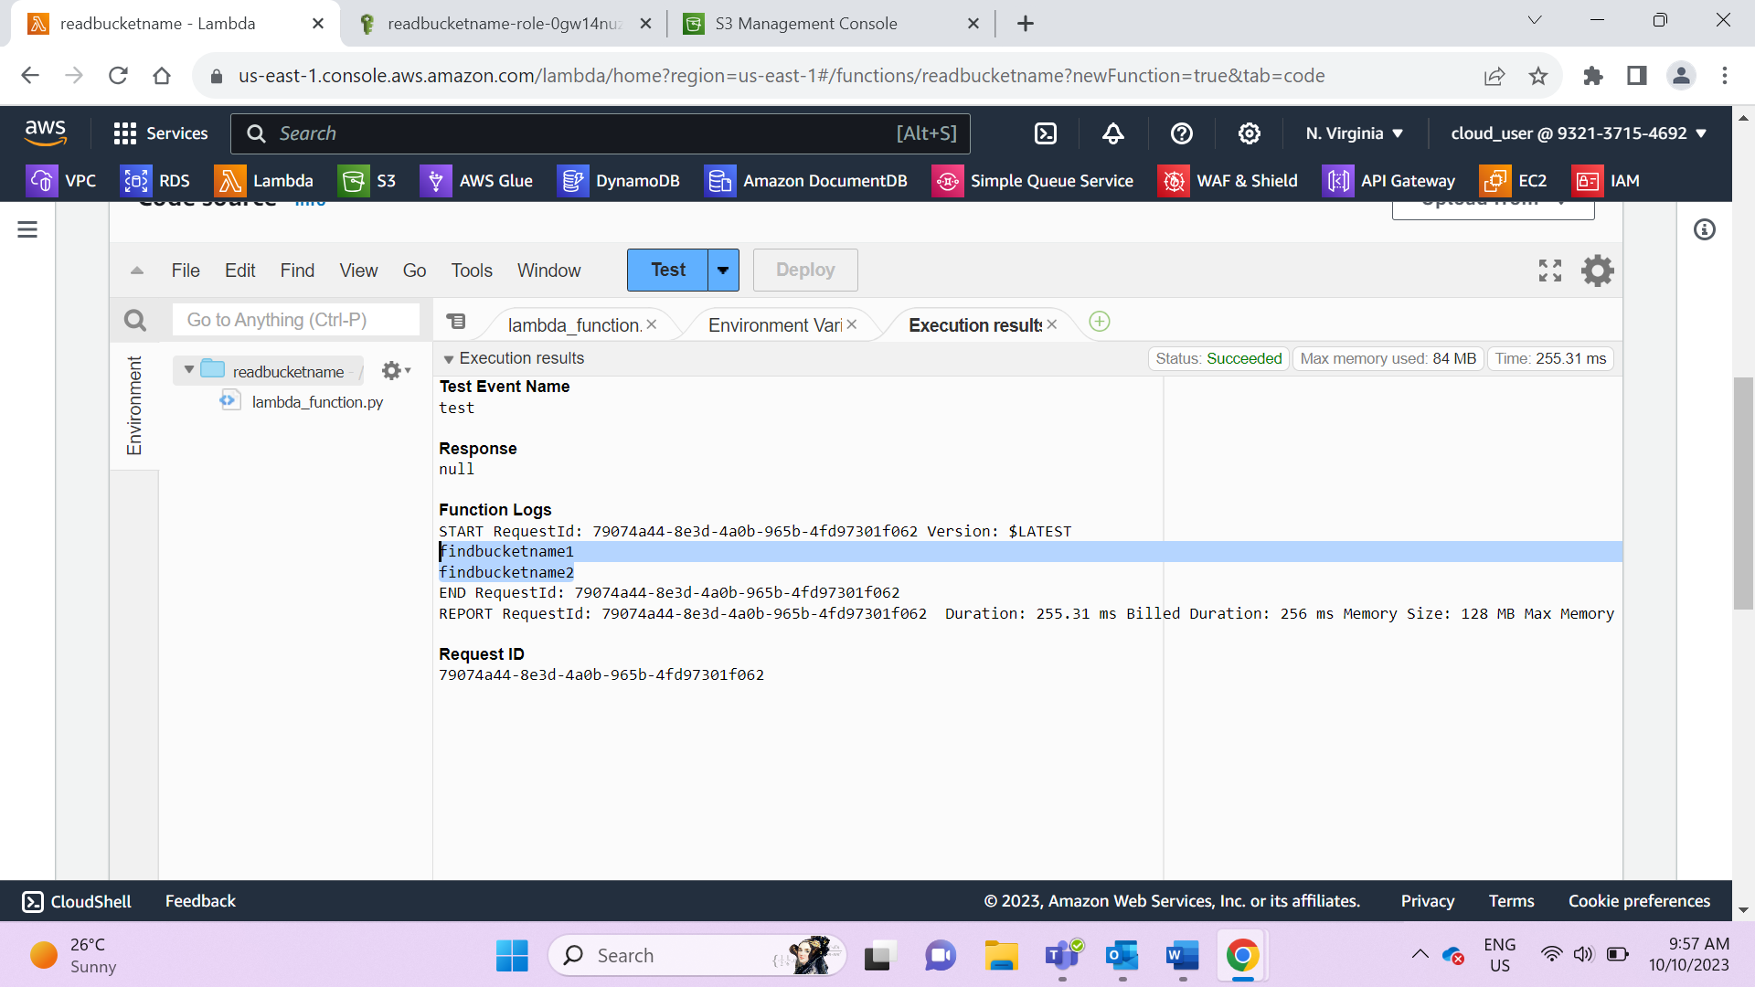

Code:

import boto3

s3=boto3.resource(‘s3’)

def lambda_handler(event, context):

for buckets in s3.buckets.all():

print(buckets.name)